COLONIAL DATABASE

Install the Colonial database and load the data using the script file available on Canvas. Write MySQL queries to answer the following questions.

1. List the trip name of each trip that has the season Late Spring.

No of Rows- 12

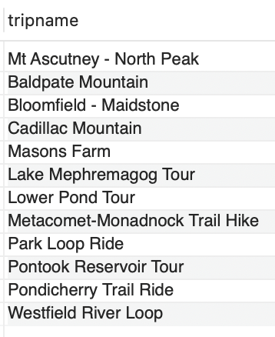

1. List the trip name of each trip that is in the state of Vermont (VT) or that has a maximum group size greater than 10.

No of Rows- 17

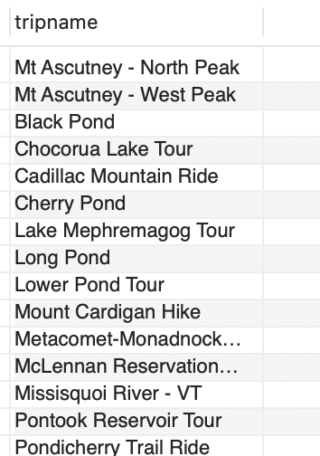

1. List the trip name of each trip that has the season Early Fall or Late Fall. No of Rows- 11

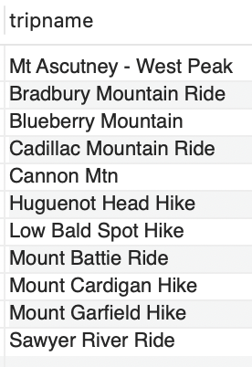

1. How many trips are in the states of Vermont (VT) or Connecticut (CT)?

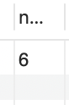

No of Rows- 1

1. List the name of each trip that does not start in New Hampshire (NH).

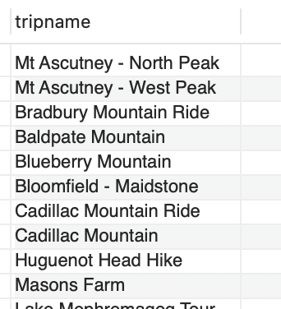

No of Rows- 22

1. List the name and start location for each trip that has the type Biking.

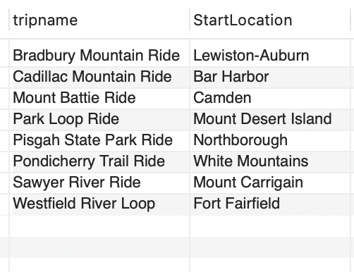

No of Rows- 8

1. List the name of each trip that has the type Hiking and that has a distance of greater than six miles. Sort the results by the name of the trip. 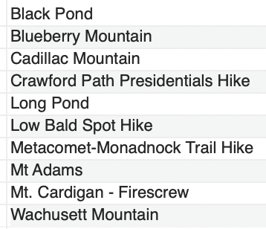

No of Rows- 10

1. List the name of each trip that has the type Paddling or that is located in Vermont (VT). 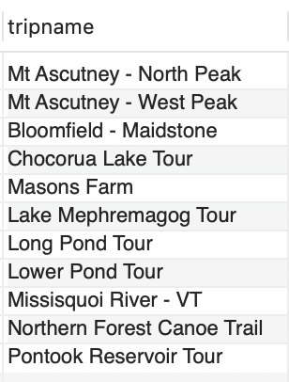

No of Rows- 11

1. How many trips have a type of Hiking or Biking?

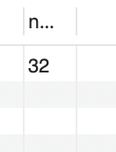 No of Rows- 1

1. List the trip name and state for each trip that occurs during the Summer season. Sort the results by trip name within state. No of Rows- 14

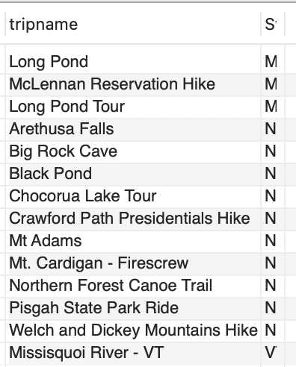

No of Rows- 14

1. List the trip name of each trip that has Miles Abrams as a guide.

No of rows-3

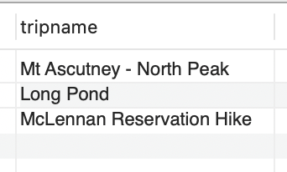

1. List the trip name of each trip that has the type Biking and that has Rita Boyers as a guide.

No of rows-4

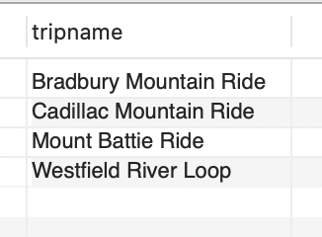

1. For each reservation that has a trip date of July 23, 2018, list the customer’s last name, the trip name, and the start location. No of rows-2

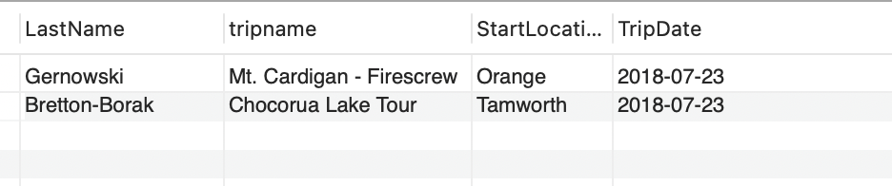

No of rows-2

1. How many reservations have a trip price that is greater than $50.00 but less than $100.00? No of rows-1

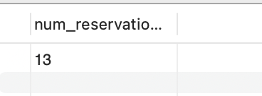

No of rows-1

1. For each reservation with a trip price of greater than $100.00, list the customer’s last name, the trip name, and the trip type.

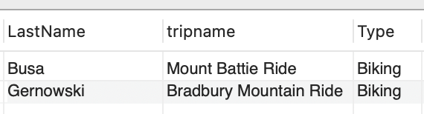

No of rows-2

1. List the last name of each customer who has a reservation for a trip in Maine (ME).

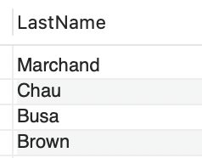

No of rows-5

1. How many trips originate in each state? Order the results by the state.

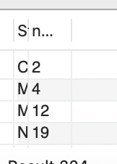

No of rows-5

1. List the reservation ID, customer last name, and the trip name for all reservations where the number of persons included in the reservation is greater than four.

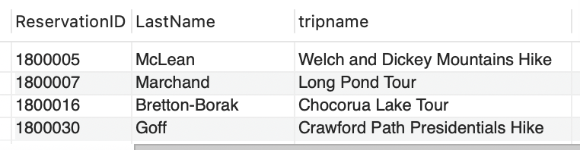

No of rows-4

1. List the trip name, the guide’s first name, and the guide’s last name for all trips that originate in New Hampshire (NH). Sort the results by guide’s last name within trip name.

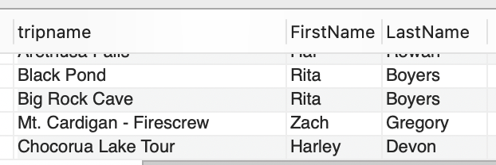

No of rows-22

1. List the reservation ID, customer number, customer last name, and customer first name for all trips that occur in July 2018.

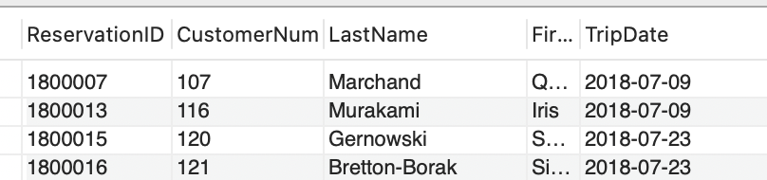

No of rows-5

1. Colonial Adventure Tours calculates the total price of a trip by adding the trip price plus other fees and multiplying the result by the number of persons included in the reservation. List the reservation ID, trip name, customer’s last name, customer’s first name, and total cost for all reservations where the number of persons is greater than four. Use the column name TotalCost for the calculated field.

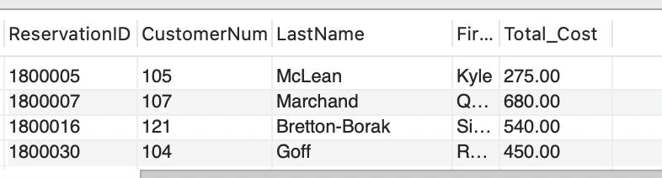

No of rows-4

1. List all customers whose first name starts with L or S. Sort the results by FirstName.

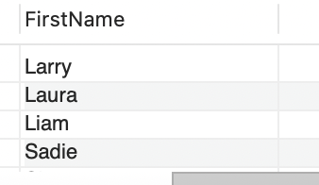

No of rows-6

1. List all the trip names whose prices are between $30 and $50.

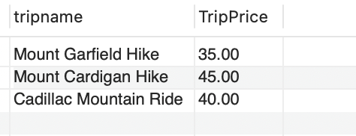

No of rows-3

1. Write a query to determine how many trips have prices between $30 and $50. (Please note that this question is different from number 23 above.)

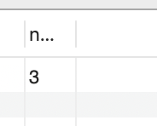

No of rows-1

1. Display the trip ID, trip name, and reservation ID for all trips that do not yet have the reservations.

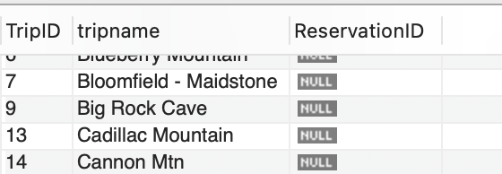

No of rows-23

1. List the trip information for each pair of trips that have the same start location.

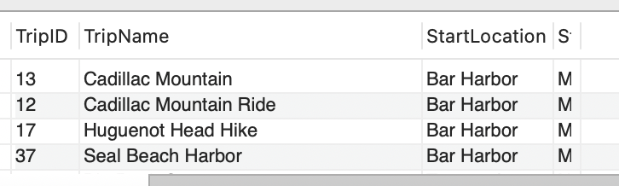

No of rows-8

1. List information for each customer that either lives in the state of New Jersey (NJ), or that currently has a reservation, or both.

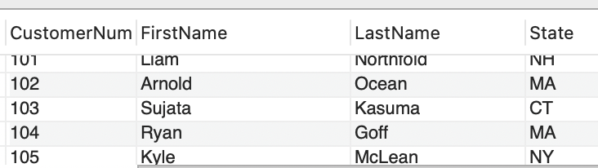

No of rows-19

1. Display all guides who are not currently assigned to any trips.

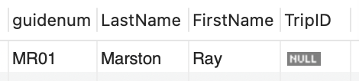

No of rows-1

1. Display the guide information for each pair of guides that come from the same state.

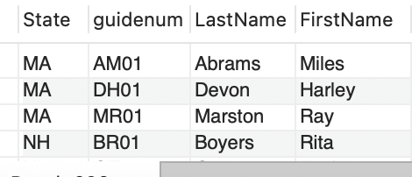

No of rows-7

1. Display the guide information for each pair of guides that come from the same city. 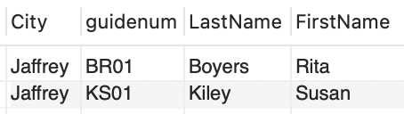

No of rows-2

ACCOUNTS PAYABLE DATABASE

Install the Accounts Payable database and load the data using the script file. Write MySQL queries to answer the following questions.

1. Select all data from the Invoices table.

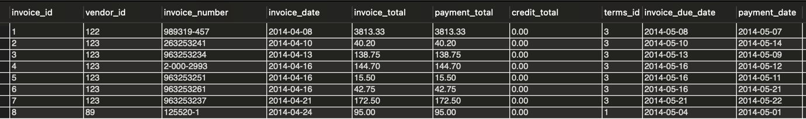

No of rows-114

1. Display the Invoice number, Invoice date, and the Invoice total. Sort in descending sequence by Invoice Total.

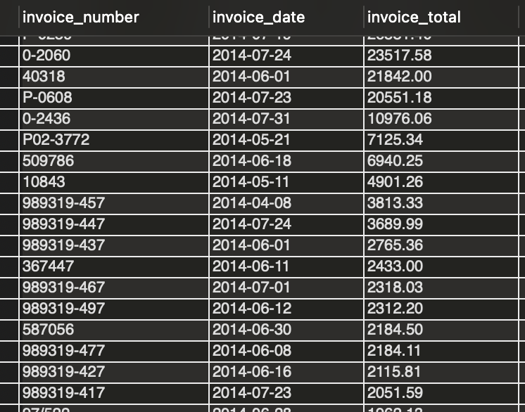

No of rows-114

1. Display all invoices from the month of June.

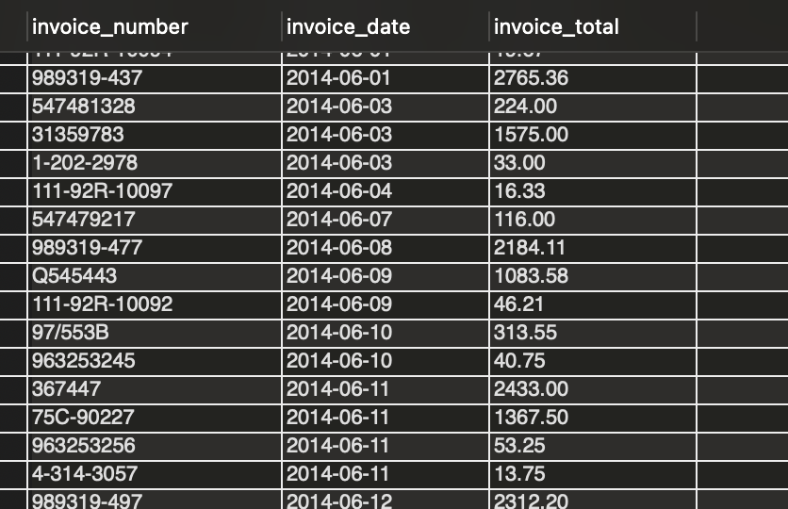

No of rows-37

1. Write a query to show all vendors. Then sort the result set by last name and then first name, both in ascending sequence.

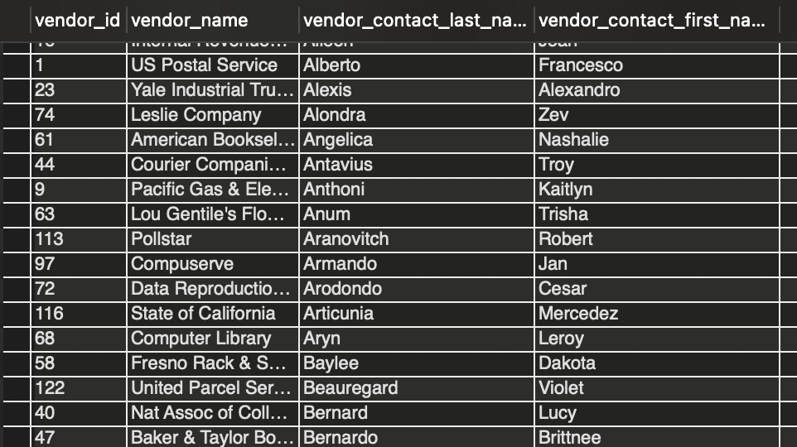

No of rows-122

1. Write a query that returns vendor’s last name and first name. Sort the result set by last name and then first name in ascending sequence. Return only the contacts whose last name begins with the letter A, B, C, E.

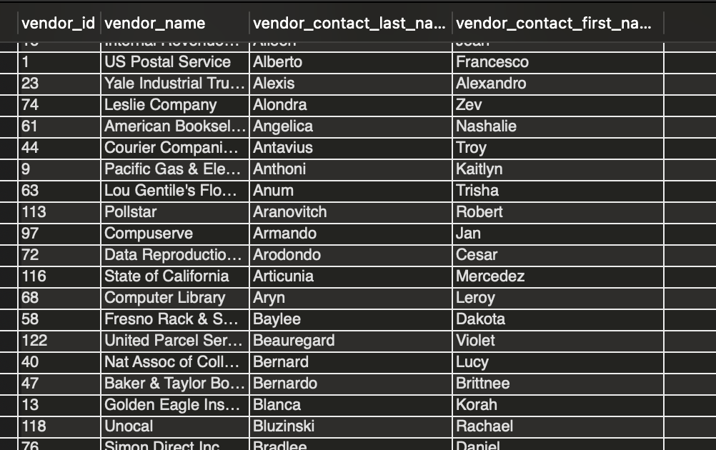

No of rows-41

1. Display the invoice due date and the invoice amounts increased by 10%. Return only the rows with an invoice total that is greater than or equal to 500 and less than or equal to 1000. Sort the result set in descending sequence by the invoice due date.

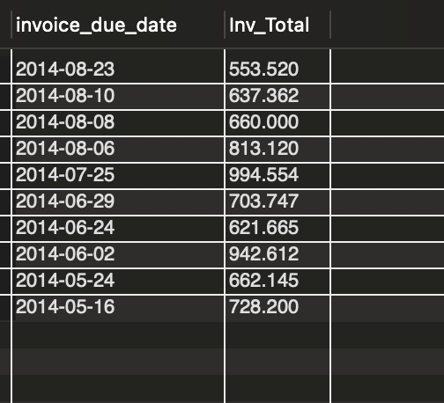

No of rows-10

1. Write a query that displays the invoice number, invoice total, payment credit total, and balance due. Return only invoices that have a balance due greater that is than $50. Sort the result set by balance due in descending sequence. Limit the result set to show only the results with the 5 largest balances.

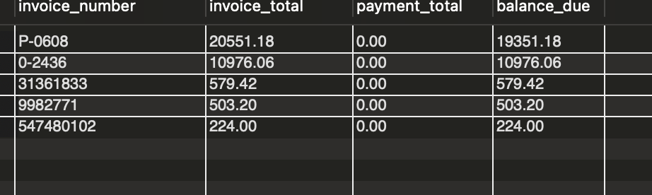

No of rows-5

1. Display the invoices which have balance due.

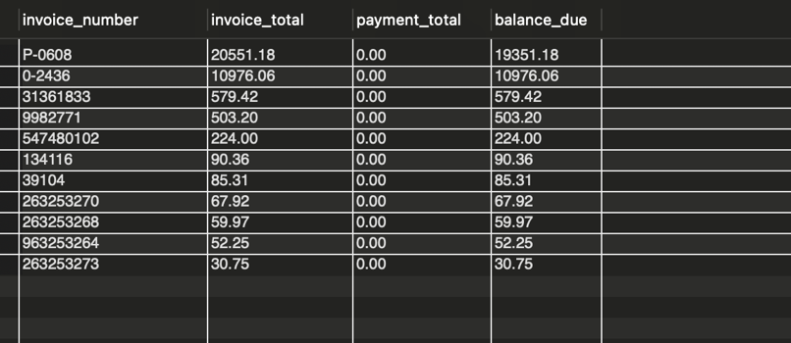

No of rows-11

1. Display the names of the vendors who have balance due.

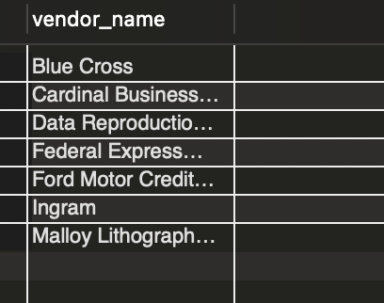

No of rows-7

1. Write a query to display information about the vendors and the default account de- scription for each vendor.

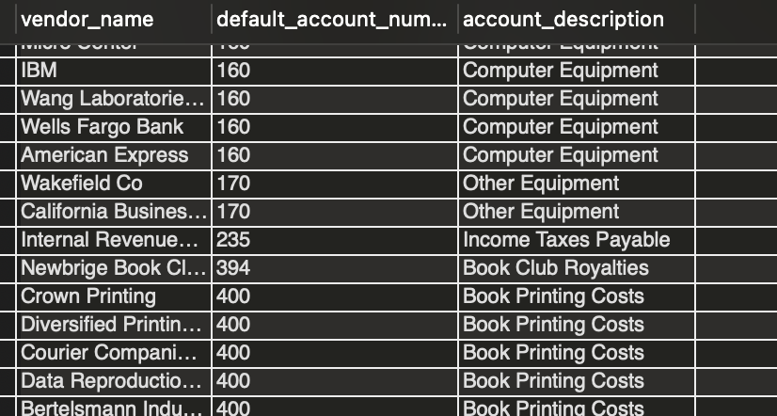

No of rows-122

1. Write a query to display all invoices for each vendor. So for example, if a vendor has 2 invoices, then display all line item information for both invoices. Just an example to give you an idea.

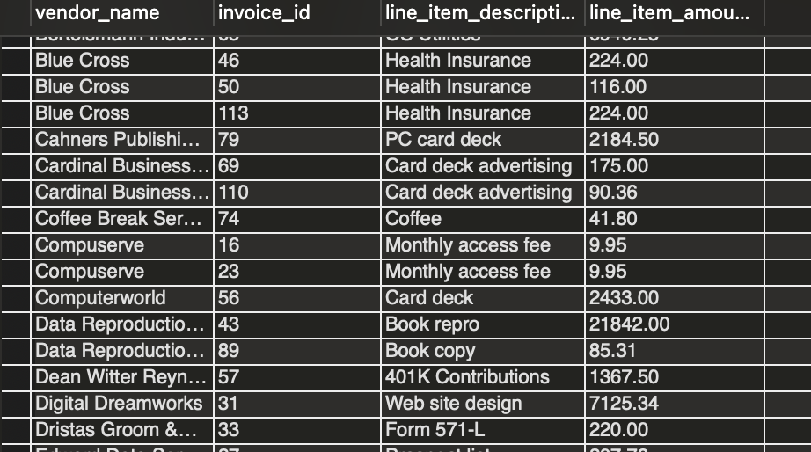

No of rows-118

1. Write a query to return one row for each vendor whose contact has the same last name as another vendor’s contact.

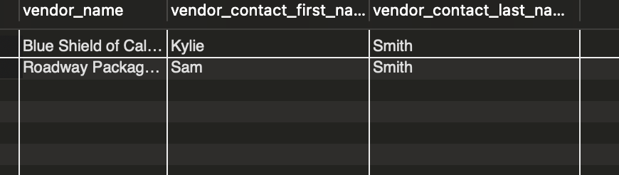

No of rows-2

1. Write a query to return one row for each account number that has never been used. Sort the result set by Account Number.

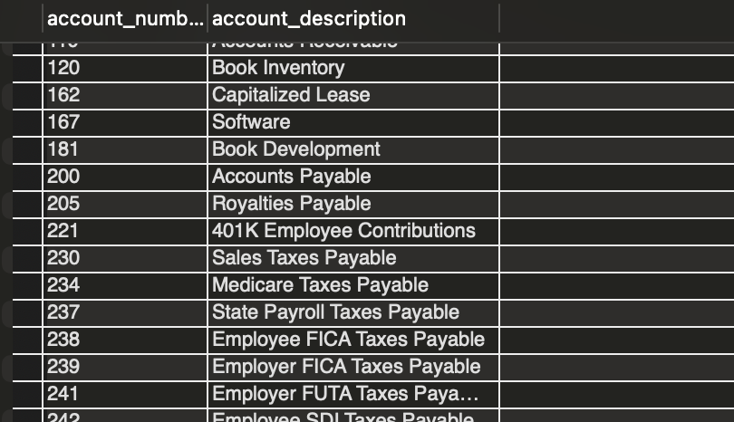

No of rows-44

1. Generate the result set containing the following columns:

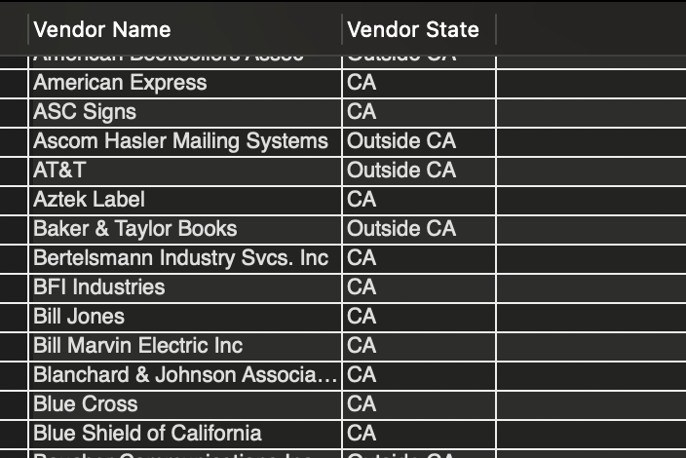

No of rows-122

Vendor Name Vendor State

If the vendor is in California, the value in the Vendor State column should be “CA”; otherwise, the value should be “Outside CA.” Sort the final result set by Vendor Name.

PRESTIGE CARS DATABASE

Install the Prestige Cars database and load the data using the script file. Write MySQL queries to answer the following questions. The database contains a small amount of data concerning sales of vehicles by a fictitious British car reseller. This database has a lot more tables than you need at this time. For this homework you need to use only the tables shown on the ER diagram. Ignore all other tables for now.

1. Display the country name and the sales region for the countries in the database.

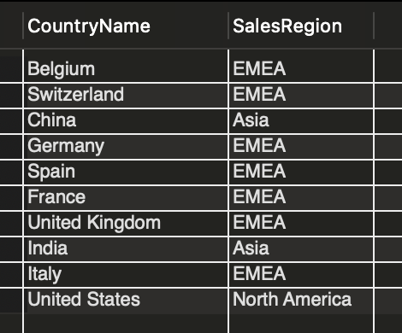

No of rows-10

1. Create a complete list of every vehicle purchased and the amount paid (cost) to pur- chase it.

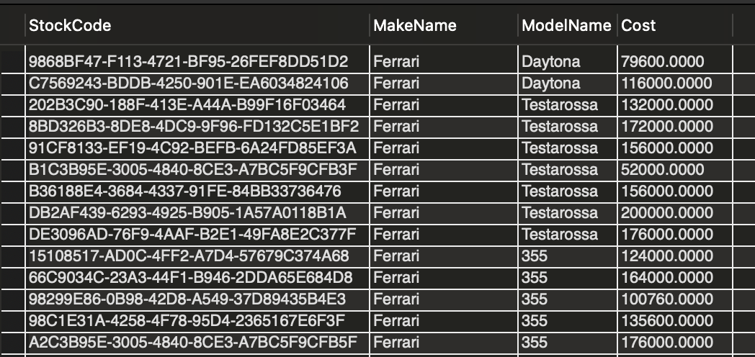

No of rows-394

1. The CEO of Prestige Cars needs to obtain a list of the countries where the company’s customers can be found. Write a query to display such a list of country names (not ISO codes.)

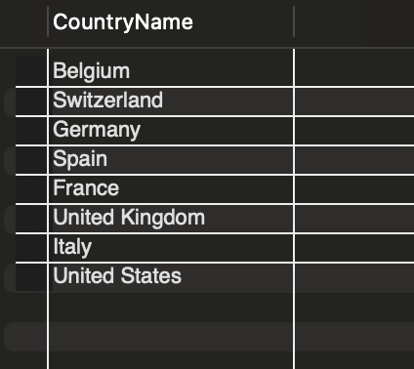

No of rows-8

1. The CEO firmly believes that effective cost control is vital for the company’s survival. She wants a list of all the cars that have ever been bought since Prestige Cars started trading. Write a query to display a list of the purchase cost for every make and model ever held in stock.

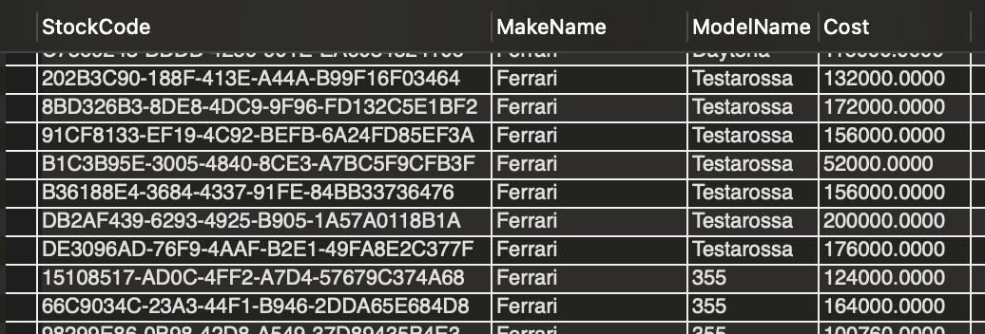

No of rows-394

1. The CEO has requested a list of all vehicles sold along with the selling price and any discounts that have been applied. Write a query to generate such a list.

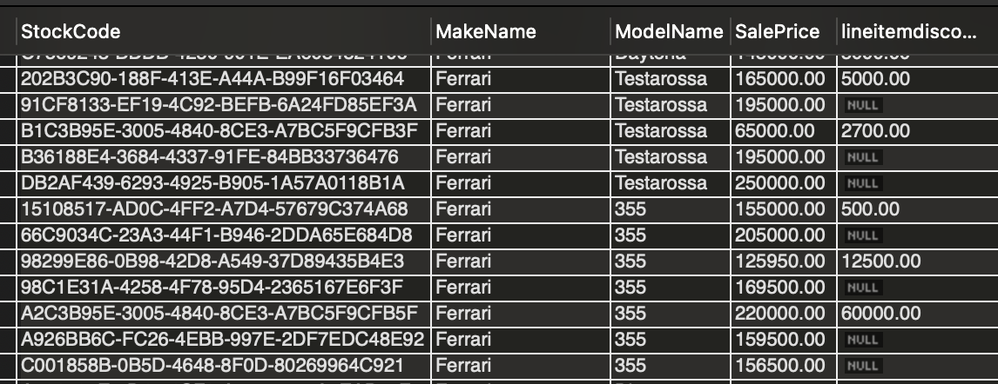

No of rows-351

1. The IT director is convinced that the database needs some cleanup. He is certain that there are makes of vehicles stored in the Make table for which there are no corresponding models. Write a query to generate a list of such makes of vehicles with no corresponding models.

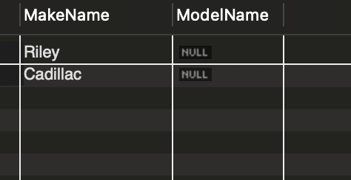

No of rows-2

1. The CEO has requested a quick list of staff so that she can produce an org chart for the next board meeting. There is a table named Staff in the database. Use this table to create a report of all staff members, their department, and their manager’s name.

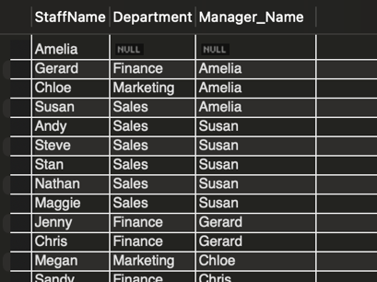

No of rows-13

1. The SalesCategory table in the database is a small table that contains the reference information that allows the sales manager to categorize each car sold according to the sale price. The sales manager wants to use the data in this table to display the specific sales category of each vehicle sold. Your result set should include the make, model, sale price, and the category description of each vehiccle sold. Write a query to generate such a list.

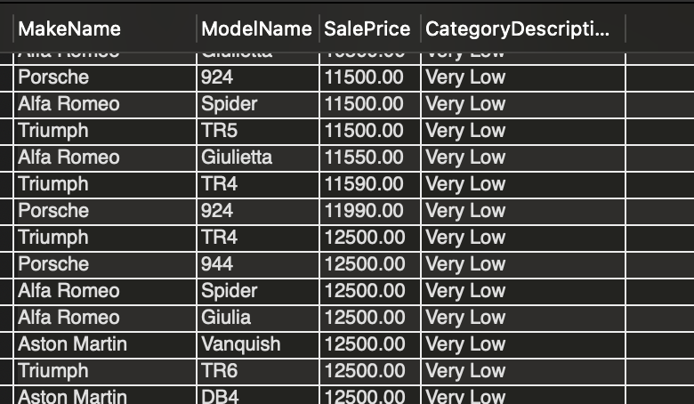

No of rows-262

1. The CEO wants a list of all countries that Prestige Cars sells to, with a list of all makes that the company has ever stocked. When you ask for more details, she says that she also wants to see every make appear for every country because this allows her to galvanize the sales teams to sell every make in every country. Write a query to generate such a list.

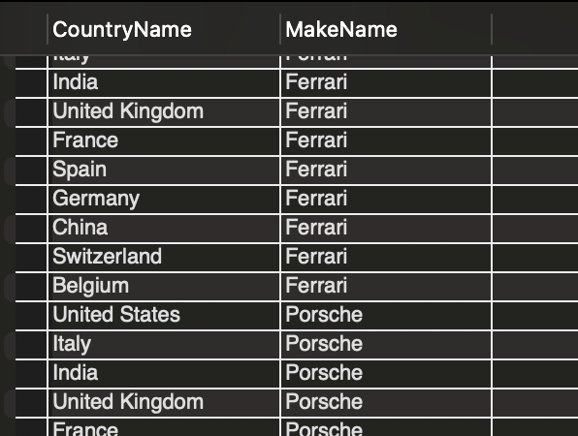

No of rows-240

1. The finance director needs to know the makes and models the company has bought and stocked. Write a query to generate a list.

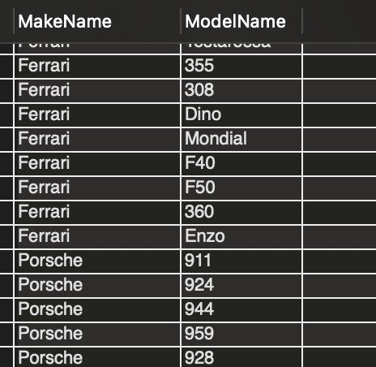

No of rows-90

1. The CEO wants a list of all models that Prestige Cars has ever sold and when they were sold. Write a query to create such a list.

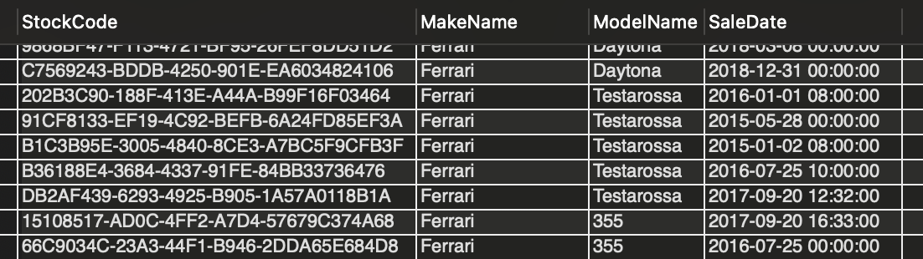

No of rows-351

1. A new marketing director has just arrived at Prestige Cars. The first thing that she wants to know is how the color of cars varies by model purchased. She wants a report displaying all the models Prestige Cars has had in stock in red, green, or blue. Write a query to generate this list.

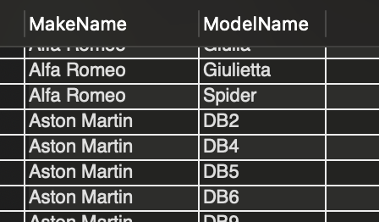

No of rows-56

1. The marketing director wants a list of all makes that were ever sold except Ferrari. Write a query to create this list.

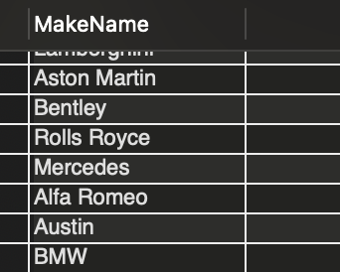

No of rows-22

1. The marketing director wants a list of all makes that were ever sold except Porsche, Aston Martin, and Bentley. Write a query to create this list.

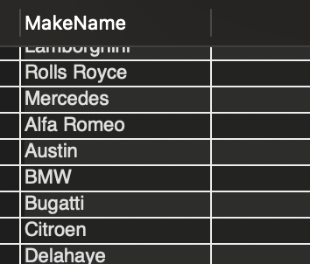

No of rows-20

1. The finance director would like to get an idea of the higher-value cars that are in stock or have been sold; more specifically, he wants to see a list of all cars where the purchase price was over £50,000.00. Write a query to generate this list.

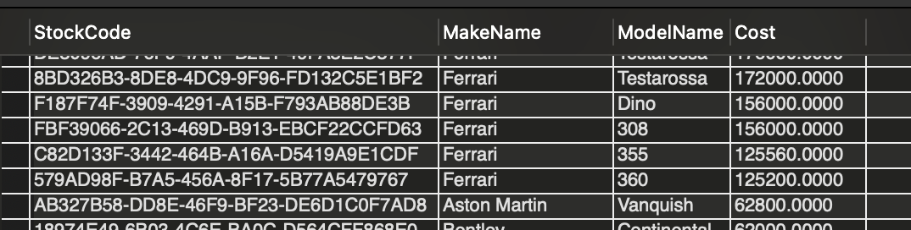

No of rows-118

1. The CEO asked for a list of all makes of car that Prestige Cars has stocked where the parts cost is between £1,000 and £2,000. Write a query to generate this list.

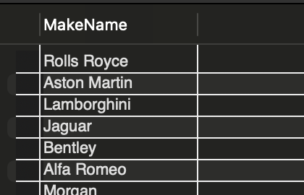

No of rows-11

1. Write a query to display the names of all make and models of the right-hand drive (RHD) models that Prestige Cars has sold.

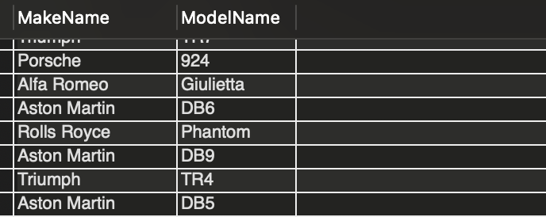

No of rows-85

1. Write a query to list all makes except Bentleys where the cars are red, green, or blue.

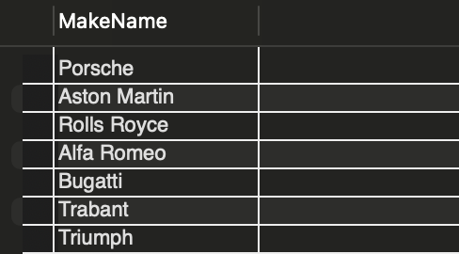

No of rows-18

1. The finance director has requested a list of all red cars ever bought where their repair cost or the cost of spare parts exceeds £1,000.00. Write a query to create this list.

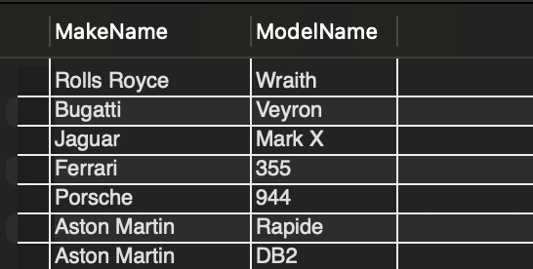

No of rows-13

1. The finance director says: “I want to see all red, green, and blue Rolls-Royce Phantoms - or failing that any vehicle where both the parts cost and the repair cost are over £5,500.00.” Write a query to create this list.

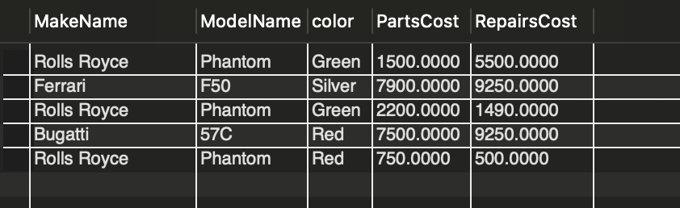

No of rows-5

1. Write a query to return the row containing the “Dark purple” vehicle. Note the case for the color. The correct query should return only one row. Hint: You can use the keyword BINARY (not the data type.)



No of rows-1

1. You have developed an excellent reputation as a data analyst at Prestige Cars. The receptionist comes to you with a request for help. She knows that Prestige Cars has a customer with Peter (or was that Pete?) somewhere in the name, and you need to find this person in the database. Create a list of all such names by using an SQL query.

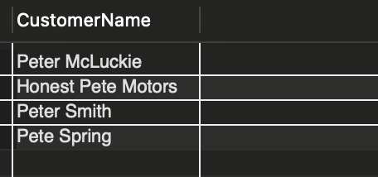

No of rows-4

1. Write a query to return all makes of the cars with capital ”L” in the name of the marque. The correct query should not return models with lowercase ”l” anywhere in the name. For example, Alfa Romeo or Bentley should not be returned. The correct query should return three rows only.

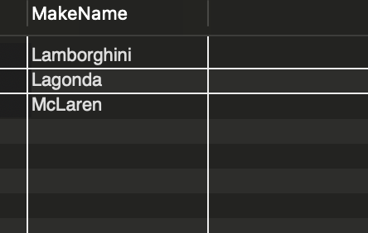

No of rows-3

1. The finance director informs you that the invoice number field is structured in such a way that you can identify the country of sale from certain characters at a specific point in the field. He wants you to use this to isolate all sales made to French customers showing the model and the invoice number for each sale made. The correct query should return 68 rows.

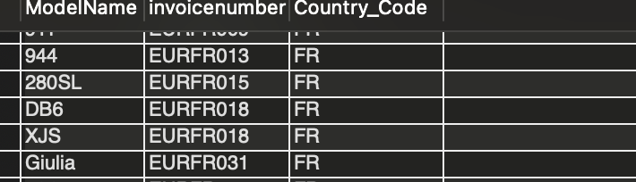

No of rows-68

Here is an example of the breakdown of the InvoiceNumber field. GBPGB001

Left three characters indicate the currency of sale, in this case GBP.  
Characters 4 and 5 indicate the destination country, in this case Great Britain.  
The last three characters provide a sequential invoice number.  
So, the invoice number GBPGB001 tells you that this sale was made in pounds sterling to a client in the United Kingdom — and is invoice No 001.

1. The marketing director has noticed that the corporate database is missing postalcodes (ZIP codes) for some clients. She has asked for a list of all customers without this vital piece of information. Write a query and create the list for the marketing director.

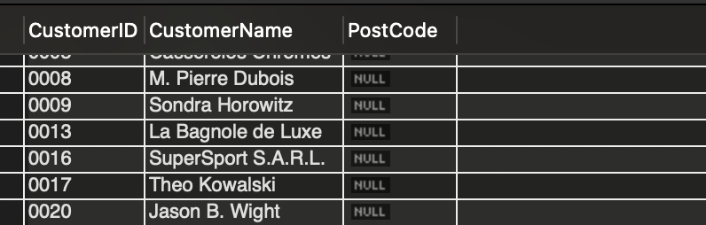

No of rows-39

1. The finance director cannot find a spreadsheet that tells him what the exact cost of every car sold is, including the purchase cost along with any repairs, parts, and transport costs. This is called the cost of sales. Using an SQL query display the make name, model name, and the total cost of every car sold.

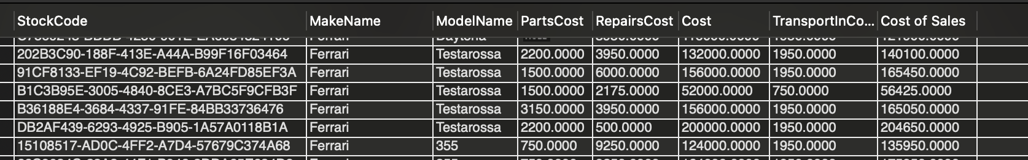

No of rows-351

1. The finance director is pleased with your cost analysis from question 26 above. He now wants you to calculate the net margin. Write a query to display the make name, model name, and the net margin.

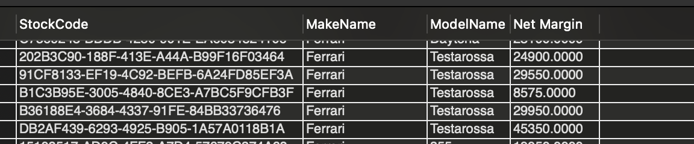

No of rows-351

1. The finance director is getting more and more excited at the thought that SQL can address every question he needs for his analysis. He now wants you to give him a list containing the ratio of cost to sales. Write an SQL query to provide this information to the finance director.

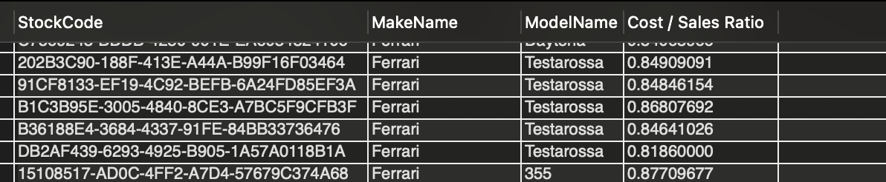

No of rows-351

1. Imagine that the sales director wants to test the improvement in margins if you in- creased the sale prices by 5 percent but kept costs the same. Using SQL, display the make name, the model name, and the improved sales margins.

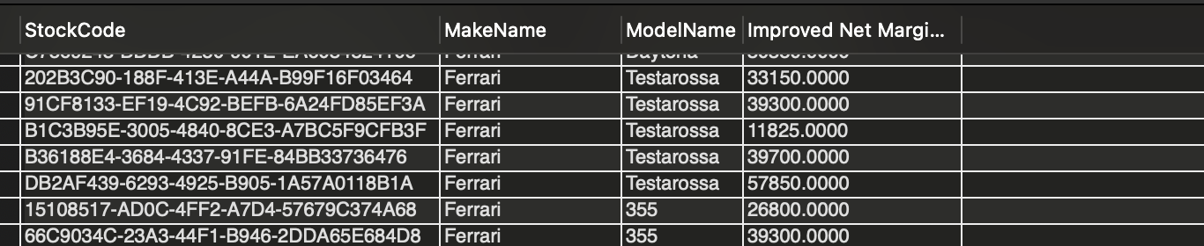

No of rows-351

1. Write a SQL query to display the make names of the models which represent 50 most profitable sales in percentage terms. Arrange your list in descending order.

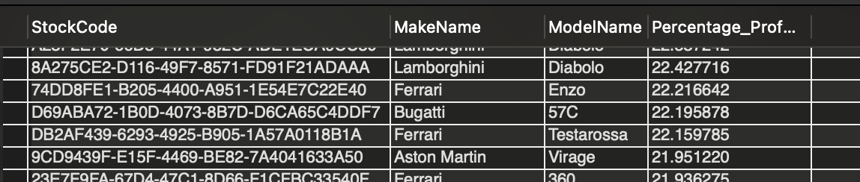

No of rows-50

1. The CEO of Prestige Cars Ltd. wants to know what the net profit is on sales. She particularly wants to see a list of sales for all vehicles making a profit of more than £5,000.00. Write a query to display this list. The correct query will return 178 rows.

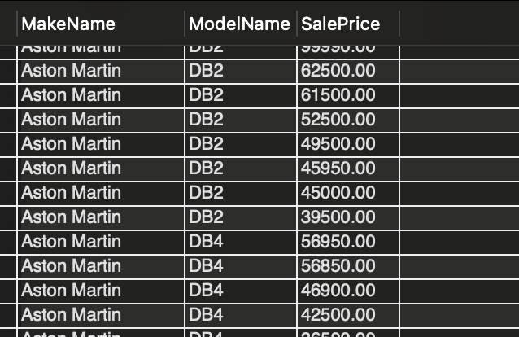

No of rows-178

1. It is late in the day, and you are thinking of heading home. Just as your eyes drift toward your lunch bag, in rushes the sales director with a request to list all car makes and models sold where the profit exceeds £5,000.00 and the car is red and the discount greater than or equal to £1,000.00 — or both the parts cost and the repairs cost are greater than £500.00. Write a query to generate this list. The correct query will return 63 rows.

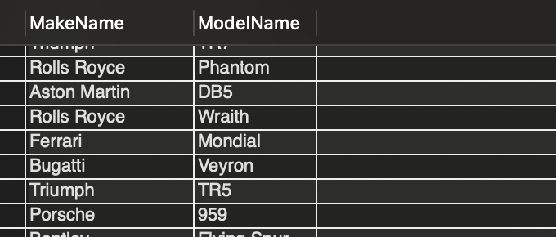

No of rows-63

1. The finance director has tasked you to calculate the aggregate sales, cost, and gross profit for all vehicles sold. Write an SQL query to provide this summary.

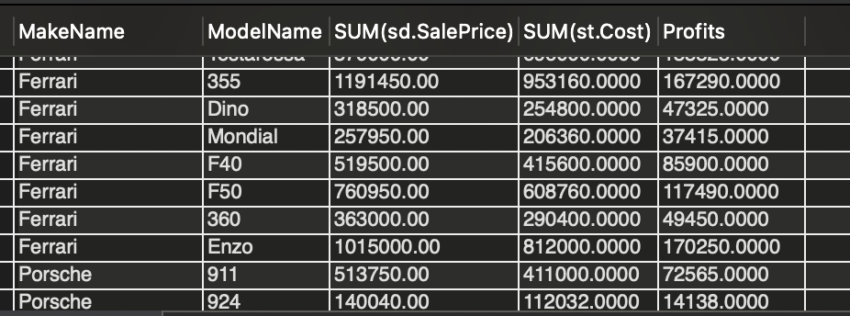

No of rows-87

1. The sales manager has emailed you with a request to calculate the aggregate cost for each model of car. Write an SQL query to provide this list to the sales manager.

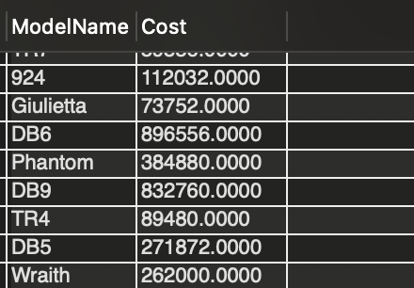

No of rows-90

1. The finance director wants you to dig deeper into the data and calculate the total purchase cost for every make and model of vehicle bought. Write an SQL query for generating this result.

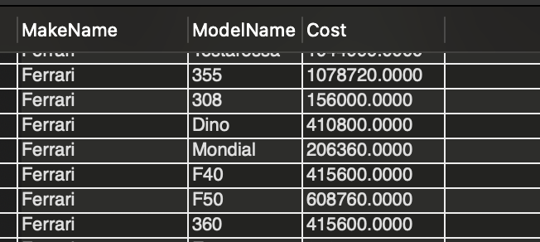

No of rows-90

1. An essential business metric is the average cost of goods bought. The finance director would want to see the average purchase price of every make and model of car ever bought. Write an SQL query to generate this list.

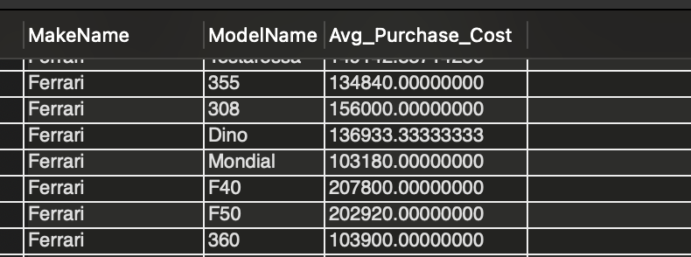

No of rows-90

1. The CEO has stated categorically that any business must be able to see at a glance how many items have been sold per product category. In the case of Prestige Cars Ltd., visualizing (not using Tableau) the number of cars sold by make and model. Write an SQL query to generate this list.

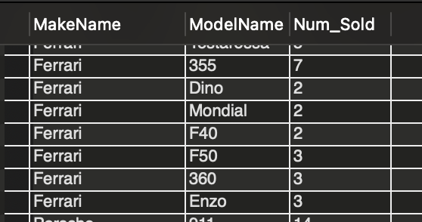

No of rows- 87

1. The sales director asked for the number of different countries that Prestige Cars has ever sold vehicles to. Write an SQL query to answer this question.

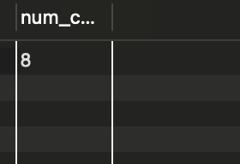

No of rows-1

1. The sales manager wants you to identify the largest and smallest sale prices for each model of car sold. Write an SQL query to generate this list. The list should contain the model name, the top sale price, and the bottom sale price for each model.

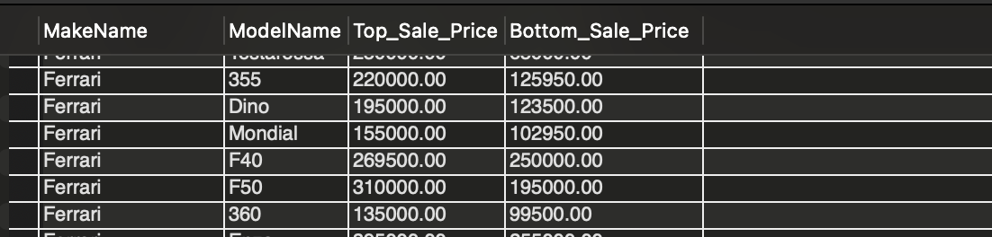

No of rows-87

1. The sales director asks you ”How many red cars have been sold for each make of the car?” Write an SQL query to create a list in response to the question. The correct query should return 13 rows.

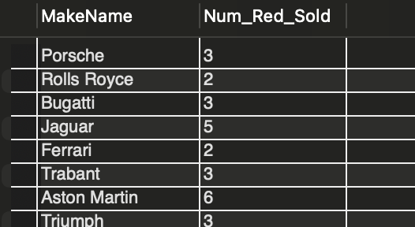

No of rows-13

1. As part of the company’s worldwide sales drive, the sales director wants to focus Prestige Cars’ marketing energies on the countries where you are making the most sales. Show the data for countries where more than 50 cars have been sold. The correct query should return only 2 rows.

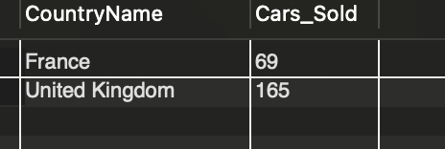

No of rows-2

1. The sales director wants to know who are the clients who have not only bought at least three cars but where each of the three vehicles generated a profit of at least £5,000.00. Write an SQL query to generate a list of such customers and the number of cars sold to such customers. The correct query should return 27 rows.

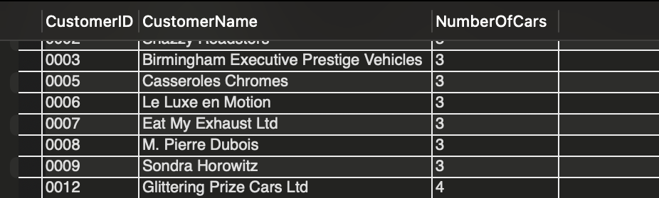

No of rows-27

1. The CEO wants to see what drives the company’s bottom line. To this end, she wants to isolate the three most lucrative makes sold so that she can focus sales efforts around those brands. Write an SQL query to identify these three most lucrative makes.

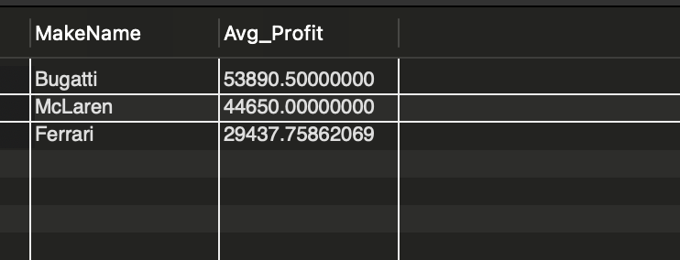

No of rows-3